Giuseppe Bongiovi

Risk Management Final Paper

Using Long Call Options for Kelly Investors

***Introduction:***

The Kelly Criterion is a utility function that optimizes the growth rate of the log wealth of a bettors wealth for a game with favorable odds. In the investment world, buying risky assets such as stock can be thought of as a gamble with some probability of profit. Literature has been worked on how to apply the Kelly criterion within the subject of finance. The Kelly Criterion often, however, requests that a Kelly investor take on more risk than he may be comfortable with, by either requesting the bettor to borrow wealth, or invest in highly volatile assets. In this paper we present two solutions for how a Kelly bettor should allocate their wealth within a single position when he requires leverage, and when he wants to reduce risk in a single position by using long call options

***Literature Review:***

The fundamental component of this paper relies on the Kelly Betting Criteria introduced in the 1956 paper by J.L Kelly. His method introduced a way for a bettor to increase his wealth optimally logarithmically in the presence of a bet that contains favorable odds by taking the expected value of the growth of wealth where p(xi) is probability of payoff xi.

$$E\left[w_{t}\right]=∑p\left(x_{i}\right)\log\left(1+fx_{i}\right)$$

Then optimizing the growth by the fraction f of wealth to bet on each iteration.

$$\frac{ⅆE\left[w_{t}\right]}{ⅆf}=Σ\frac{p\left(x_{i}\right)x_{i}}{1+fx_{i}}=0$$

By betting fraction f on each bet for a favorable bet, a bettor will have the largest growth of wealth over any other betting scheme.

Thorp(2006) then extends this result for a distribution symmetrical around the mean for a normal distribution. His result for the fractional value f to invest in risky asset with mean μ, standard deviation σ, and risk free rate r

$$f=\frac{μ-r}{σ^{2}}$$

Using this formula, which can also be derived using a Taylor expansion, can recommend leverage for a position or f greater than 1. Using leverage can introduce unnecessary risk into the portfolio. It introduces margin risk, which can end a trade before the trade has time to develop to a significant degree and makes a trade weak to outlier events causing the borrower to owe more than expected in the event of a loss. This is due to a weakness in the assumption of a normal distribution of returns. Many financial timeseries data is plagued with higher moments inconsistent with a normal distribution with high skew and kurtotic distributions. The literature attempts to reconcile this notion of using leverage for investors who are risk averse by optimizing the growth rate of wealth subject to constraints such as no shorting securities and that total fractional wealth used is equal to 1. However, the optimization naturally consolidates bets from a larger universe of stocks into a much smaller subset, which can be counterproductive for growth when the trade turns against a trader. Wesselhofft and Hardle analyze the Kelly optimization program for a portfolio with Value at Risk(VAR) constraints. For low VAR, we see that the portfolios optimize heavily into treasury bonds. We see that when he introduces puts into the portfolios, the optimal Kelly portfolios diverge in returns with the Kelly portfolios with puts outperforming the Kelly portfolios with no puts for the same VAR constraint.

In this paper we analyze the two problems presented above using Long Calls when a risky asset requires leverage for 1 asset, and how to reduce risk for a wealth constrained Kelly position using long calls which is equivalent to a being long stock and buying a put.

***Methodology:***

For the risky Investor attempting to use Kelly Leverage f, borrowing at high levels a leverage may not be recommended due to risk of a margin call before the complete conclusion of a trade. Thorps Kelly formula assumes that you can borrow at risk free rate r to leverage a position to Kelly levels. In the Black Scholes Merton model of Option pricing. The European Call closed form solution is as follows:

$$C\left(S_{t},t\right)=N\left(d_{1}\right)S_{t}-N\left(d_{2}\right){ke}_{}^{-r\left(T-t\right)}$$

$$d_{1}=\frac{1}{σ\sqrt{T-t}}\left\{\ln\left(\frac{S_{t}}{k}\right)+\left(r+\frac{σ^{2}}{2}\right)\left(T-t\right)\right\}$$

$$d_{2}=d_{1}-σ\sqrt{T-t}$$

Where St is the price of the underlying at time t, T is the expiration time , k is the strike price of the option. The price of the call option can be separated into two terms: C = Extrinsic + Intrinsic where Intrinsic = St – K. the Leverage given by buying an option at strike K is St/(St – K). Each option has its own Extrinsic value associated with it. For In the Money Options, we can consider this premium on top of the Intrinsic price as an Interest rate paid upfront by the buyer of the option. The rate paid by the buyer is Roption = Extrinsic/k. if we plot the Interest rate of the option for each strike for an in the money option we see that the rate paid by the buyer of the option approaches the risk free rate used in the closed form solution for an asset with no dividend. If we then use the interest rate for each option in the calculation of the Kelly leverage, then there is a leverage of an option that will match the leverage matched by the Kelly criterion. We show both these results below for each option strike k:

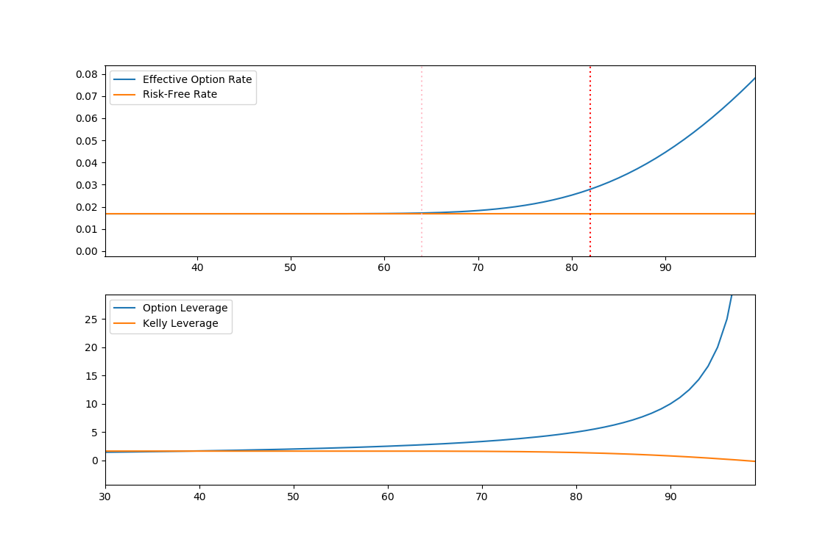

In our calculations for this example, we used μ = 0.07 and σ = 0.18, the two vertical lines are the 1st and 2nd standard deviation around 100 for the calculation. As we can see, for each strike K, there is an interest rate we pay upfront on K dollars and for each Kelly calculation there is a option leverage that will match our calculated Kelly leverage.

Using these results we construct three different portfolio compositions and back test them against historical data with constraints of being long only, the trader decides not to trade if the kelly leverage is negative. In our back-test the trader can buy European options and buys them at the Kelly Leverages, in one portfolio the trader invests all his capital in the Kelly leveraged position. In the other portfolio, the trader trades only the profits of his portfolio from the previous time-step. Lastly we check a Value at Risk(VAR) constrained portfolio, where the trader buys options at a prespecified VAR limit and invest a percentage of his portfolio in the option and the rest in bonds. We check for risk free bonds and AAA bonds using historical data and different levels of VAR.

***Data and Results:***

The data used in our back-test is daily data for the SP500 from 1989 to 2019 from yahoo finance. We also gather daily data for 1-year treasury bills from the St. Louis federal reserve website and Moody’s AAA bond yield from the St. louis federal reserve website. we calculate the mean and variance for 3 years’ worth of data and use the 1-year treasury bill rate to calculate hypothetical option prices for SP500 European options, we assume no dividend in the calculation of the option prices. We calculate the returns for the timestep and then move the data forward 1 year and repeat the process. In all we have 30 out of sample returns. For the blue portfolios below, the portfolio does not trade for the first year, for the red and green portfolios, the portfolio is increased by AAA bond rate for that year.

Half- Kelly Log Returns Full-Kelly Log Returns

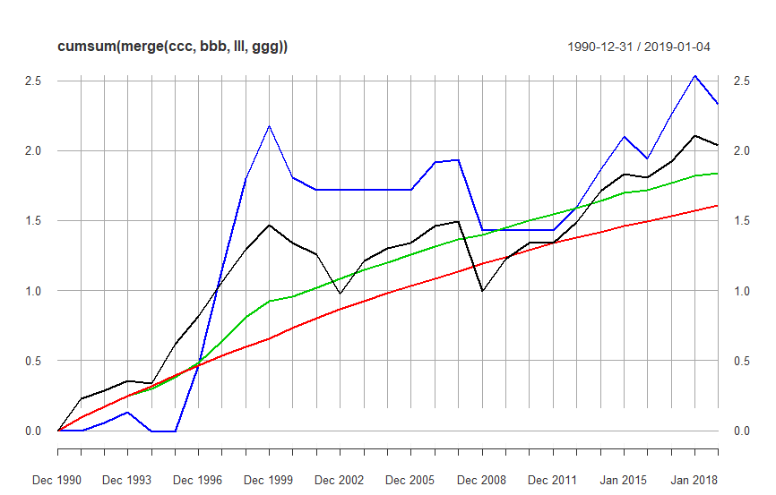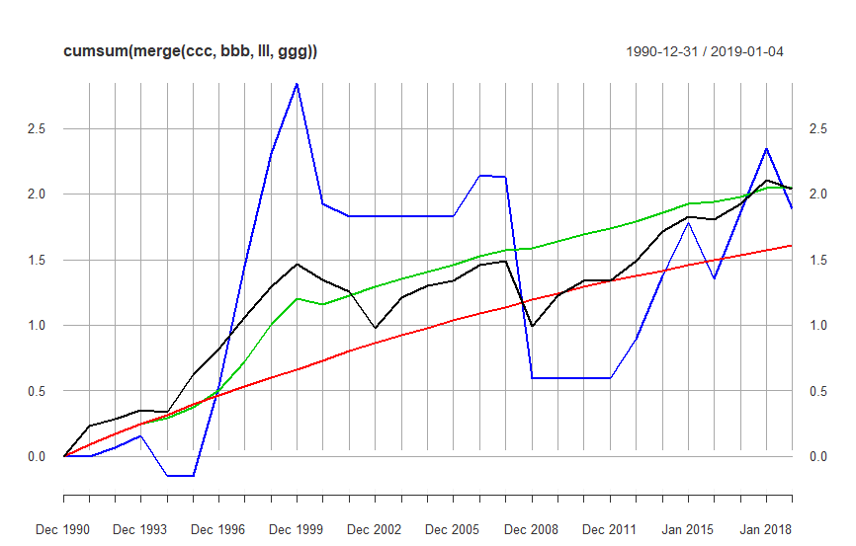

Figure 1.

*Black: SP500 returns, Blue: Half-Kelly Options, Green: Half Kelly profit only else AAA, Red: AAA bonds only*

In our analysis we see results that are consistent with the literature, that the half-Kelly is more conservative and more reliable than the full Kelly portfolio. We agree with these statements due to the weaknesses presented in the approximation method and the distributions of financial assets. Since financial assets are skewed and kurtotic, any heavily skewed and kurtotic distribution heavily impacts the quality of the approximation given by thorp and the model breaks down.

|  |  |  |  |  |
| --- | --- | --- | --- | --- |
|  | Kelly_factor/2 | half Kelly returns_log | Kelly_factor | full Kelly returns_log |
| 1 | 2.316009 | 0.057993 | 4.578878 | 0.067074 |
| 2 | 1.002288 | 0.072636 | 1.60444 | 0.092615 |
| 3 | 3.317881 | -0.14032 | 6.546288 | -0.31195 |
| 4 | 0 | NA | 0 | NA |
| 5 | 3.880607 | 0.470878 | 7.746533 | 0.683542 |
| 6 | 5.083856 | 0.679958 | 9.96957 | 0.917723 |
| 7 | 5.36691 | 0.661886 | 10.40022 | 0.857251 |
| 8 | 3.073704 | 0.377163 | 5.912316 | 0.534305 |
| 9 | 2.208989 | -0.37375 | 4.337058 | -0.91624 |
| 10 | 1.000791 | -0.08904 | 1.033504 | NA |
| 11 | 0 | NA | 0 | NA |
| 12 | 0 | NA | 0 | NA |
| 13 | 0 | NA | 0 | NA |
| 14 | 0 | NA | 0 | NA |
| 15 | 2.082477 | 0.198533 | 4.163782 | 0.311886 |
| 16 | 1.73593 | 0.016465 | 3.494298 | -0.01336 |
| 17 | 1.000681 | -0.50043 | 1.977962 | -1.53769 |
| 18 | 0 | NA | 0 | NA |
| 19 | 0 | NA | 0 | NA |
| 20 | 0 | NA | 0 | NA |
| 21 | 1.122664 | 0.163027 | 2.255312 | 0.302369 |
| 22 | 1.217243 | 0.26787 | 2.451997 | 0.479782 |
| 23 | 2.215265 | 0.240221 | 4.290552 | 0.406735 |
| 24 | 5.810842 | -0.16274 | 10.87844 | -0.42384 |
| 25 | 3.274428 | 0.321733 | 6.276616 | 0.510473 |
| 26 | 1.58241 | 0.271765 | 3.180804 | 0.476162 |
| 27 | 2.407201 | -0.20012 | 4.767616 | -0.45208 |

*Figure2. Kelly factors agreed by algorithm based on Extrinsic value of option and log returns of option.*

We can see from the data that on a few occasions that the Kelly criterion allowed leverages in excess of what is possible to be able to hold long term, on event 24 we have a full Kelly leverage of 10.8 and on event 7 which is during the 90s bull market and contributed to the most excess returns of any dates. The full Kelly leverage allowed the green portfolio in figure 1 that only traded on net profits from previous year to keep pace with the market portfolio with most of the returns happening during the 90s bull market. However, we can see that trading a full Kelly portfolio is incredibly risky and results in wild swings of portfolio value. A more conservative Kelly investor may want to restrict the total amount of possible capital to deploy on any trade and may want to restrict losses on a VAR format. Below we show data relating to different VAR portfolios investing in 1-year treasuries or AAA bonds.

**VAR 20%,1year Treasuries: Log Returns**

*Figure 3. Portfolio weights in option at VAR % and 1 year treasury Black: VAR portfolio, Red: SP500*

**VAR 40%,1year treasuries: Log Returns**

*Figure 4. Portfolio weights in option at VAR % and 1 year treasury Black: VAR portfolio, Red: SP500*

VAR 20 log(returns)

Min. :-0.20070

Median : 0.08586

Mean : 0.07136

Max. : 0.23989

VAR 40 log(returns)

Min. :-0.46795

Median : 0.08812

Mean : 0.06182

Max. : 0.26453

In figures 3 and 4 we see the power of a drawdown constraint in action. This portfolio is equivalent to being long the stock and buying a put at the corresponding strike that limits VAR to a specified constraint. We see that during bull market years, the market outperforms the VAR portfolio due to the expense of buying the insurance. Because the VAR 20 portfolio bought the insurance however, during recessions and market corrections, the portfolio outperforms the benchmark and continues to stay ahead for the remainder of the out of sample return. The VAR 40 portfolio does not see the same amount of strength. Because the VAR 40 portfolio elected to take on more risk and pay less for the insurance as a result, it is only protected during the financial crises and the 2001 dot com crash. The VAR portfolio experiences a large drawdown during these periods and as such it did not out perform as severely as the VAR 20 portfolio because it was forced to suffer most of the losses the market experienced. What is interesting to see, is the lack of outperformance of the market portfolio during the bull market of 10’s. it is believed this can be attributed to the low volatility environment experienced through the 10’s driving the price of calls and puts down. The behavior we see is consistent with Wesselhofft and Hardle. They see that the application of puts to a Kelly portfolio allows the portfolio to perform very well as it limits the drawdown of a risky portfolio.

We then compare VAR portfolios where we invest in riskier AAA bonds instead of risk-free treasury where the yield of AAA bonds is greater than the yield on 1 year treasury bonds. Because the yield on AAA bonds are higher, what is expected is that cost of insurance is diminished because the yield of the AAA bonds subsidizes the insurance while also covering the risk free rate that is included in the cost of a long option call. We show the behavior below.

**VAR 20% AAA Log Returns**

*Figure 5. VAR invested in SP500 and rest invested in AAA bonds*

*Black: VAR portfolio, Red: SP500*

**VAR 40% AAA Log Returns**

*Figure 6. VAR invested in SP500 and rest invested in AAA bonds*

*Black: VAR portfolio, Red: SP500*

var20 log(returns)

Min. :-0.169698

Median : 0.117016

Mean : 0.091615

Max. : 0.261522

|  |
| --- |
| VAR 40 log(returns)  Min. :-0.44756  Median : 0.11152  Mean : 0.07729  Max. : 0.27041 |

As in the figure 3 and 4 portoflios, the use of options is utilized to get the returns to leverage up as if we were fully invested in the underlying stock minus the extrinsic value , which we can consider the interest to borrow from the portfolio. We see as in figures 3 and 4, the max drawdown of the two VAR portfolios is restricted because of the use of options, however in the portfolios for figures 5 and 6, the portfolios completely outperform the market portfolio. Over the first 20 years of the portfolio, we see that the market outperforms the VAR portfolio and that can be attributed to the cost of the Extrinisc value hampering the returns. After the 2008 financial crisis and the out performance during these corrections, the two VAR portfolios are able to outperform because of the spread between the 1 year rates and the AAA bonds. Because the rates on 1 year bonds were close to zero and volatiltiy was lower, the large spread allowed the AAA bonds to subsidize the options and allow the Invested bonds to actually grow in value. The drawdown restriction imposed by buying the option and the strategy of reinvesting the rest of the cash in AAA bonds allowed the VAR portfolio to significantly outperform the regular market. It is believed that this strategy is optimal for a kelly investor that does not want to borrow to outperform. Because we are not only limiting drawdown due to the options as in Wesselhofft and Hardle,but buying the calls instead allows an investor to keep cash on hand to invest. The kelly investor can then use the available cash to invest in significantly less risky assets, whose role is to subsidize the insurance cost of the kelly portfolio. The insurance cost is the main driver of underperformance from an asset for a Kelly investor who wants to limit drawdown.

***Conclusion:***

In this paper, two solutions are looked at for a Kelly investor. One solution involves the Kelly investor looking to maximize their leverage for a favorable bet within the market and an algorithm is presented that allows the Kelly investor to choose the right option for the Kelly leverage. It is seen that using leverage is a double edged sword and that an accurate forecast is required for the Kelly investor who wishes to use leverage to capitalize on the market conditions and not take unacceptable losses. The second solution is for a Kelly investor who invests in a chosen Kelly asset with no leverage who wants to limit drawdown in the risky asset. The Kelly investor who invests in the risky asset should buy a call option at a specified VAR limit instead of the underlying stock, then with the remaining cash allocated to the position, invest the cash into a much less risky asset whose role is to subsidize the insurance cost and risk free rate that is the extrinsic value of an option. Because the asset has a VAR limit, the risk in the risky asset itself is well defined and the growing value of the less risky asset such as in AAA bonds allows the overall portfolio to outperform in total should the return of the less risky asset exceed the extrinsic value of the option or the risky asset have a negative return that exceeds the VAR limit.

***References:***

[1] N. Wesselhofft, W.K. Hardle, Risk-Constrained Kelly Portfolio Under Alpha-Stable Laws, August 2019, Computational Economics, Springer, https://doi.org/10.1007/s10614-019-09913-y

[2] C.H. Hsieh, B.R. Barmish, On Kelly Betting: Some Limitations, 2015, Fifty third annual Allerton Conference

[3] W.T. Ziemba, Understanding the Kelly Capital Growth Investment Strategy

[4] M. Wu, W. Chung, A Novel Approach of Option Portfolio Construction Using The Kelly Criterion, 2018,IEEE Access.

[5] B.J. Kelly, A New Interpretation of Information Rate , 1956, AT&T

[6] E. O. Thorp, The Kelly Criterion in BlackJack Sport Betting and the Stock Market, 2006, Handbook of Asset and Liability Management, Volume 1, Chapter 9.

CODE:

library(quantmod)

library(RConics)

library(PerformanceAnalytics)

library(moments)

BS <-

function(S, K, T, r, sig, type="C"){

d1 <- (log(S/K) + (r + sig^2/2)*T) / (sig*sqrt(T))

d2 <- d1 - sig*sqrt(T)

if(type=="C"){

value <- S*pnorm(d1) - K*exp(-r*T)*pnorm(d2)

}

if(type=="P"){

value <- K*exp(-r*T)*pnorm(-d2) - S*pnorm(-d1)

}

return(value)

}

logdiff = function(d){

len = length(d[,1])

rets = d[,]

for(j in 1:length(rets[1,])){

rets[1:len,j] = diff(log(rets[,j]))

}

rets = rets[2:len,]

return(rets)

}

OPToption = function(ra,price,mu,sigma,r_free){

f = mu/(sigma*sigma)/ra

k = c()

for(i in 1:floor(price)){

Bsmc = BS(price,i,1,r_free,sigma,type = "C")

Intrinsic = price - i

Extrinsic = Bsmc - Intrinsic

Interest = Extrinsic/i

#print(Extrinsic)

Leverage = price/(price - i)

#print((f - Interest/(sigma*sigma)) - Leverage)

if(((f - Interest/(ra*sigma*sigma)) - Leverage) <= 0.02){

k = rbind(i,Bsmc,Leverage)

break

}

}

return(k)

}

dataset = xts()

data <- getSymbols("^GSPC",from = "1989-01-01", to = "2019-11-02", src = 'yahoo')

dataset = Ad(get("GSPC"))

#data = getSymbols("^VIX",from = "1987-01-01", to = "2019-10-23", src = 'yahoo')

#dataset = merge(dataset,Ad(get("VIX")))

data <- getSymbols("AAA",from = "1989 - 01-01",to = "2019-11-02", src = "FRED")

dataset2 = xts()

dataset2 = (get("AAA"))

data <- getSymbols("DGS1",from = "1989 - 01-01",to = "2019-11-02", src = "FRED")

dataset2 = merge(dataset2,(get("DGS1")))

dataset2 = dataset2[(7654:length(dataset2[,1])),]

dataset2[1,2] = 9.11

class(dataset2)

class(dataset)

ddd = merge(dataset,dataset2)

ddd = ddd[complete.cases(ddd)]

for(i in 1:length(dataset2[,2])){

if(is.na(dataset2[i,2]) == TRUE){

dataset2[i,2] = dataset2[(i-1),2]

}

if(is.na(dataset2[i,1]) == TRUE){

dataset2[i,1] = dataset2[(i-1),1]

}

}

ddd = merge(dataset,dataset2)

ddd = ddd[complete.cases(ddd)]

#initial value of bond portfolio.

#we want to trade only AAA rated bonds in the portfolio however returns are allowed to be traded

#in an attempt to maximize growth, how should we trade?

#we can either keep it in AAA rated bonds or we can trade in the SP500

#you get penalized for losing basically

#we need an algorithm to get best option to buy

Lrets = logdiff(ddd$GSPC.Adjusted)

ddd2 = merge(ddd,Lrets)

ddd2 = ddd2[complete.cases(ddd2)]

lever = c(0)

lever = as.matrix(lever)

ra = 2 #risk aversion parameter aka half kelly = 2 full kelly = 1

pVAR = rbind(1000000,1000000)

Pkelly = rbind(1000000,1000000)

Portfolio_value = c(1000000) #starting portfolio value

Portfolio_value = as.matrix(Portfolio_value)

rownames(Portfolio_value)[1] = c(as.character(index(ddd2[(252*2),2]))) #portfolio return dates we are denoting returns for that fiscal year, if year end starts at 1991 then the returns are for year 1990

rownames(lever)[1] = c(as.character(index(ddd2[(252*2),2])))

Portfolio_value = rbind(Portfolio_value,Portfolio_value[1]*(1+as.numeric(ddd2[1,2])/100)) #need 1 step to get profits

lever = rbind(lever,0)

rownames(lever)[2] = c(as.character(index(ddd2[(252*3),2])))

rownames(Portfolio_value)[2] = c(as.character(index(ddd2[(252*3),2])))

Benchmark = Portfolio_value

SPX = c(ddd2[(252*2),1],ddd2[(252*3),1])

rownames(SPX) = c(rownames(Benchmark))

checks = c()

for(i in 1:(floor(length(ddd2[,1])/252)- 3 )){

ts = 1 + 252*(i-1)

tf = 252*3 + 1 + 252*(i-1)

m = mean(ddd2[(ts:tf),4])

s = sd(ddd2[(ts:tf),4])

var = 0.2 #value at risk factor, 0 < var < 1 denotes how much of portfolio you risk in market

BSVAR = BS(as.numeric(ddd2[tf,1]),as.numeric(ddd2[tf,1])*(1-var),1,as.numeric(ddd2[tf,3])/100,s,type = "C")#Optionsprice where we keep VAR at 20% of portfolio

payVAR = as.numeric(ddd2[(tf + 252),1]) - as.numeric(ddd2[tf,1])*(1-var)

pVAR = rbind(pVAR,((1-var)*pVAR[i+1]*(1 + as.numeric(ddd2[tf,2])/100) + var*max(payVAR,0)*pVAR[i+1]/BSVAR))

#pVAR = rbind(pVAR,((1-var)*pVAR[i+1]*(1 + as.numeric(ddd2[tf,3])/100) + var*max(payVAR,0)*pVAR[i+1]/BSVAR))

#pVAR = rbind(pVAR,((1-var)*pVAR[i+1]*(1) + var*max(payVAR,0)*pVAR[i+1]/BSVAR))

f = (m*252 - as.numeric(ddd2[tf,3])/100)/(s*s*252)

play_money = 0

if(Portfolio_value[i+1] - Portfolio_value[i] > 0){ #the trader can only trade last years profits, trader is punished by not being able to trade if returns are too low

play_money = Portfolio_value[i+1] - Portfolio_value[i]

}

else{

play_money = 0

}

ppp = c()

if( f > 1){

ppp = OPToption(ra,as.numeric(ddd2[tf,1]),m*252,s*sqrt(252),as.numeric(ddd2[tf,3])/100)

f = ppp[3]

payoff_option = max((ddd2[(tf + 252),1] - ppp[1])*1*(play_money/ppp[2]),0)

pkelly_option = max((ddd2[(tf + 252),1] - ppp[1])*1*(Pkelly[i+1]/ppp[2]),0)

}

else if(f < 0){ #trader can only be long. i dont have a system for buying puts, so trader is long AAA bonds in this scenario

f = 0

play_money = 0

payoff_option = 0

pkelly_option = Pkelly[i+1]

}

else{ #if leverage is less than 1 trader can choose to just be long shares of SPX at some fraction of portfolio profits and be long AAA bonds with the rest

f = f/ra

play_money = f*play_money

payoff_option = play_money + play_money*sum((ddd2[(tf:(tf + 252)) , 4]))

pkelly_option = Pkelly[i+1] + Pkelly[i+1]*sum((ddd2[(tf:(tf + 252)) , 4]))

}

weight = c(1 - play_money/Portfolio_value[i + 1], play_money/Portfolio_value[i + 1])

Pkelly = rbind(Pkelly,pkelly_option)

total_return = weight[1]*Portfolio_value[i + 1]*(1+ddd2[tf,2]/100) + max(payoff_option,0)

net = total_return - Portfolio_value[i+1] #portfolio returns

net_option = payoff_option - play_money #cash returns on kelly bets

netpercent = log(payoff_option/play_money) #log returns of kelly bets

Portfolio_value = rbind(Portfolio_value, as.numeric(total_return)) #update portfolio value

x = c(play_money,f,weight,payoff_option,net,net_option,netpercent)

x = t(x)

checks = rbind(checks,x)

lever = rbind(lever,f)

Benchmark = rbind(Benchmark, as.numeric(Benchmark[i+1]*(1+ddd2[tf,2]/100)))

SPX = rbind(SPX,ddd2[tf + 252,1])

rownames(SPX)[i+2] = c(as.character(index(ddd2[(tf + 252),2])))

rownames(Benchmark)[i + 2] = c(as.character(index(ddd2[(tf + 252),2])))

rownames(Portfolio_value)[i + 2] = c(as.character(index(ddd2[(tf + 252),2])))

rownames(lever)[i + 2] = c(as.character(index(ddd2[(tf + 252),2])))

}

colnames(checks) = c("play_money","Kelly_factor/2","weight_AAA","Weight_Kelly","payoff_option","net_returns","Kelly_returns","Kelly_returns_%")

#plot(cumsum(Lrets),type = "l")

Pkelly = as.matrix(Pkelly)

rownames(Pkelly) = c(rownames(Portfolio_value))

rownames(pVAR) = c(rownames(Portfolio_value))

lll = log(as.xts(as.matrix(Portfolio_value)))

lll = diff(lll)

lll[1] = 0

bbb = log(as.xts(as.matrix(Benchmark)))

bbb = diff(bbb)

bbb[1] = 0

ccc = log(as.xts(as.matrix(SPX)))

ccc = diff(ccc)

ccc[1] = 0

ggg = diff(log(as.xts(Pkelly)))

ggg[1] = 0

qqq = diff(log(as.xts(pVAR)))

qqq[1] = 0

plot(as.xts(lever), type = "l")

plot(cumsum(merge(ccc,bbb,lll,ggg)),type = "l")

x = c(sd(ccc)/sd(lll),sd(lll - bbb))

plot(cumsum(merge(qqq[3:length(qqq)],ccc[3:length(ccc)])))

qqq[3:length(qqq)] - ccc[3:length(ccc)]